Büchen, September 2026

BLOHM is expanding its range of services to include profile grinding of rotors and worms
Cost-effective machining of complex profiles

As the machinery park continues to grow, so too does the range of services that BLOHM can offer its customers in the field of contract manufacturing. The current range of services now includes, amongst others, high-precision profile grinding of rotors and worms. This gives customers from pump, transmission and compressor manufacturing sectors access to a specialised machining process without having to invest in the relevant machinery themselves.

A profile grinding machine from Klingelnberg is one of the latest additions to the BLOHM machine park. This means that, in addition to internal and external cylindrical grinding, the specialists for precision components can also undertake the grinding of complex rotor and worm profiles for their customers. The process is suitable for the manufacture of prototypes and single parts and for the production of small and large batches.

Profile grinding differs fundamentally from conventional cylindrical or surface grinding processes. Whilst simple geometries are predominantly machined here, profile grinding produces highly complex profiles through the precise interaction of a profiled grinding wheel and synchronised multi-axis motion. This enables the production of complex geometries with very tight tolerances.

These machined components are used in various industrial sectors. Rotors are used, amongst other things, in screw pumps, compressors, metering pumps and volumetric meters. Worm profiles can be found in e.g. worm gear drives such as those used in hoists, conveyor systems and steering systems. A recent example of a BLOHM manufacturing operation is ground worm shafts for a customer in the gearbox industry. The blank parts are supplied and BLOHM then carries out the entire grinding process of the worm profiles.

The Klingelnberg H10 enables machining in the micrometre range
A Klingelnberg H10 is used. The machine can machine workpieces with a centre-to-centre distance of up to 900 millimetres and a machining length of up to 500 millimetres. The minimum possible free circle diameter begins at 5 millimetres, the maximum outside diameter is 150 millimetres. Machining operations in the micrometre range is possible, depending on the specific component geometry.

With the Klingelnberg H10, BLOHM has expanded its existing range of machining services to include a specialised process for complex rotationally symmetrical components. This provides customers from a range of industries with additional options for the cost-effective machining of complex components.

(characters including spaces: 2.659)

Short profile of NORMTEILWERK ROBERT BLOHM
NORMTEILWERK ROBERT BLOHM, founded in Schleswig-Holstein in 1934, is a renowned manufacturer of drill bushes and sophisticated customised solutions. The company also offers its customers a comprehensive range of standard and operating parts. For more than 90 years, BLOHM has been an internationally renowned specialist for the production of rotationally symmetrical parts and has always stood for the highest precision and quality.
Our portfolio comprises around 46,000 high-quality products that can, thanks to their stability, withstand high loads, and also fulfil special requirements. We are therefore primarily targeting partners from trade and industry who rely on durable, high-quality parts. We have high-performance, state-of-the-art machinery for the production of precision parts at our disposal. Possible areas of application for the various bushes and standard parts are machine, special machine and plant construction as well as mould and tool making. We value long-term partnerships with our customers, highest quality and timely delivery. Looking to the future, we have also been training the next generation of skilled workers for decades.

(characters including spaces: 1.201)

Image overview:
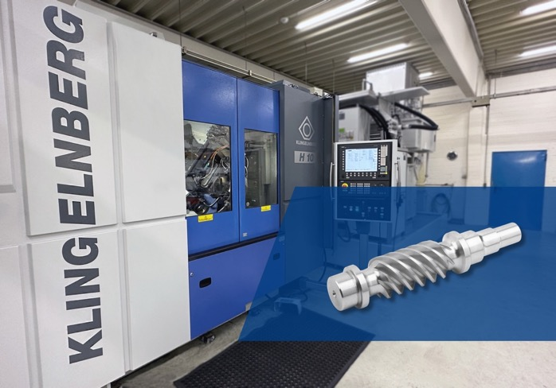
Using a Klingelnberg profile grinding machine, BLOHM, as a contract manufacturer, carries out the grinding of complex rotor and worm profiles.
Image: NORMTEILWERK ROBERT BLOHM GmbH

Meta title: Profile grinding – available from BLOHM

Meta description: Using a Klingelnberg profile grinding machine, BLOHM, as a contract manufacturer, undertakes the grinding of complex rotor and worm profiles.

Keywords: NORMTEILWERK ROBERT BLOHM, BLOHM, standard parts, operating parts, drill bushes, contract manufacturing, contract manufacturer, grinding technology, profile grinding, rotor profiles, worm gear profiles, worm shafts, pump manufacturing, transmission manufacturing, compressor manufacturing

Deeplinks:
https://www.blohm-gmbh.de/de/de/Home.html
https://www.blohm-gmbh.de/de/de/News/BLOHM-News/Neue-Maschine-schafft-neue-Möglichkeiten.html

Download-Area: https://www.blohm-gmbh.de/de/de/Download/Pressebereich.html

NORMTEILWERK ROBERT BLOHM GmbH
Adriana Klink
Bahnhofstraße 20
21514 Büchen
Telephone: +49 7454 793-7648
Fax: +49 7454 793-133
Email: adriana.klink@blohm-gmbh.de

Press office:
Köhler + Partner GmbH
Brauerstrasse 42 • 21244 Buchholz i.d.N.
Telephone +49 4181 92892-0 • Fax +49 4181 92892-55
info@koehler-partner.de • www.koehler-partner.de

