Büchen, April 2026

Stainless steel drill bushes from BLOHM
Where moisture or aggressive media are part of the process

Not every drill bush is used in a dry, clean and predictable environment. In many processes, the reality is different: Moisture, cleaning cycles or aggressive media are part of everyday life. This is exactly where BLOHM comes in with a stainless steel drill bush portfolio.

Stainless steel drill bushes are a good choice wherever corrosion is to be expected or stainless materials are specified. Typical applications are in the foodstuff sector, the pharmaceutical and chemical industries and outdoor use. In principle, stainless steel drill bushes from BLOHM offer a robust solution in all manufacturing environments where moisture, cleaning agents or chemicals are regularly present.

Users benefit in several ways: Tight manufacturing tolerances as well as hardened and ground surfaces ensure repeat accuracy and reliable tool guidance, reduced tool wear and therefore ensure economical and stable processes in batch production. These drill bushes are wear-resistant, corrosion-resistant and dimensionally stable. Properties that also make them interesting for automated production lines, as the process quality remains constant over long periods of time.

336 items, two versions, with and without collar
BLOHM's stainless steel drill bush portfolio currently comprises a total of 336 items. These include 168 DIN 179 type cylindrical drill bushes and 168 DIN 172 type flanged drill bushes. Flanged drill bushes are used when axial retention is required. The collar serves as a mechanical stop. Cylindrical drill bushes are used where the bush is to be completely sunk into the holder. Although the DIN 172 and DIN 179 standards have now been officially withdrawn, they are still regarded as the market standard and are used by BLOHM as a reference.

Both product families are available as Form A with a radius one end and Form B with radii both ends. The internal diameters are between 2 and 25 mm for Form A and 2.5 and 25 mm for Form B. While Form A is typically used for simple, single-sided fixtures, Form B is suitable for applications with alternating machining directions. The radii on both sides enable tool-friendly entry and exit regardless of the installation direction.

A large number of variants are available from stock and can therefore usually be supplied at short notice. Customised designs can also be implemented on request.

(characters including spaces: 2.556)

Short profile of NORMTEILWERK ROBERT BLOHM
NORMTEILWERK ROBERT BLOHM, founded in Schleswig-Holstein in 1934, is a renowned manufacturer of drill bushes and sophisticated customised solutions. The company also offers its customers a comprehensive range of standard and operating parts. For 90 years, BLOHM has been an internationally renowned specialist for the production of rotationally symmetrical parts and has always stood for the highest precision and quality.
Our portfolio comprises around 46,000 high-quality products that can, thanks to their stability, withstand high loads, and also fulfil special requirements. We are therefore primarily targeting partners from trade and industry who rely on durable, high-quality parts. We have high-performance, state-of-the-art machinery for the production of precision parts at our disposal. Possible areas of application for the various bushes and standard parts are machine, special machine and plant construction as well as mould and tool making. We value long-term partnerships with our customers, highest quality and timely delivery. Looking to the future, we have also been training the next generation of skilled workers for decades.

(characters including spaces: 1.254)

Image overview:
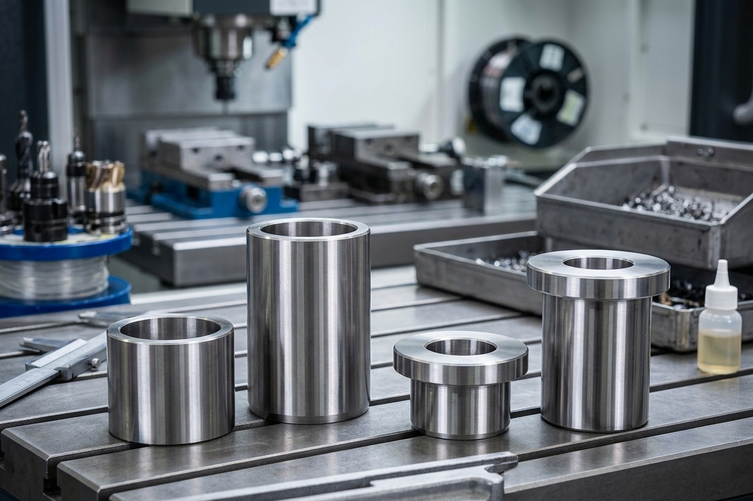
Stainless steel drill bushes from BLOHM are a good choice wherever corrosion is to be expected or stainless materials are specified. Tight manufacturing tolerances and hardened and ground surfaces ensure repeatable and reliable tool guidance, reduced tool wear and therefore ensure economical and stable processes.
Image: NORMTEILWERK ROBERT BLOHM GmbH

Meta title: Stainless steel drill bushes from BLOHM

Meta description: The stainless steel drill bush portfolio from BLOHM includes cylindrical drill bushes and flanged drill bushes with a radius one end or both ends.

Keywords: NORMTEILWERK ROBERT BLOHM, BLOHM, standard parts, operating parts, drill bushes, stainless steel drill bushes, foodstuff technology, pharmaceutical industry, chemical industry

Deeplinks:
https://www.blohm-gmbh.de/de/de/Home.html
https://www.blohm-gmbh.de/de/de/Produkte/Produktübersicht/Bohrbuchsen.html
https://www.blohm-gmbh.de/de/de/Produkte/Produktübersicht/Bohrbuchsen/Bohrbuchsen/Zylindrische-Bohrbuchsen-Edelstahl-DIN-179.html
https://www.blohm-gmbh.de/de/de/Produkte/Produktübersicht/Bohrbuchsen/Bohrbuchsen/Bundbohrbuchsen-Edelstahl-DIN-172.html

Download-Area: https://www.blohm-gmbh.de/de/de/Download/Pressebereich.html

NORMTEILWERK ROBERT BLOHM GmbH
Adriana Klink
Bahnhofstraße 20
21514 Büchen
Telephone: +49 7454 793-7648
Fax: +49 7454 793-133
Email: adriana.klink@blohm-gmbh.de

Press office:
Köhler + Partner GmbH
Brauerstrasse 42 • 21244 Buchholz i.d.N.
Telephone +49 4181 92892-0 • Fax +49 4181 92892-55
info@koehler-partner.de • www.koehler-partner.de

