Büchen, April 2024

NORMTEILWERK ROBERT BLOHM: Top precision since 1934

BLOHM celebrates 90 years of drill bushes

A landmark anniversary, and good cause to celebrate – BLOHM’s drill bush is turning 90 and is as popular as ever. The industrial sector welcomed the precision product with open arms right from the start of its production in 1934. In the meantime, the drill bush has joined the ranks of numerous other standard and operating parts as well as countless customised special solutions. Since 2021, BLOHM has been contributing its long experience in the fields of turning, hardening and precision grinding to the KIPP Group as one of its successful business units.

In the ever-changing history of NORMTEILWERKS ROBERT BLOHM, there has always been one reliable constant – the drill bush. Launched in 1934, the current portfolio now comprises more than 3000 types of product. Common to all is their high quality and micron precision, the result of decades of expertise, a high vertical range of manufacture and a clear commitment to Germany as a business location.

“Industry was quick to recognise the reliability of BLOHM products,” says CEO Otto Braun, looking back to the early days. “The company expanded so strongly in such a short time that it soon became necessary to move from Hamburg city centre to Bergedorf. In 1957, drill bush production was relocated from the Bergedorf plant to Büchen in Schleswig-Holstein, where it is still based today.”

NORMTEILWERK ROBERT BLOHM received its present name in 1974, when drill bush production was separated from the company’s machinery division of the company, not only physically but also legally, and was subsequently managed by the Blohm family. In 1999, the Blessing family took over the business until BLOHM became part of the Kipp Group in 2021, another long-standing family-run company with its headquarters in Sulz am Neckar in Baden-Württemberg.

Shared values, shared goals
“The union of BLOHM and KIPP is a perfect fit, not only because of our product portfolios, but also because of our traditions and values,” says Otto Braun. “Both companies stand for responsibility, dynamism and fairness – the basis of our success is a corporate philosophy we live and work by. We place great value on a customer-centred approach and long-term partnerships with our customers. We stand for top quality and reliable delivery, something for which we are also valued beyond the borders of Germany as a manufacturing system supplier.”

Quality made in Germany
BLOHM’s current range of products and services includes the production of high-precision drill bushes and customised special solutions as well as a range of around 35,000 high-quality standard and operating parts, which is being expanded continuously. Customers benefit not only from modern, high-performance machinery and a high vertical range of manufacture, but also from the many years of experience of the company’s workforce of around 50.

BLOHM is well-positioned for the future. In addition to continuous development of further new products and training of new skilled workers, the training company is also focussing on the digitalisation of sales and production. “We will continue to optimise both our processes and our portfolio over the next few years,” Otto Braun sums up. “With creativity and innovation, we will evolve into a successful unit within the KIPP Group.”

(Characters including spaces: 3,422)

Short profile of NORMTEILWERK ROBERT BLOHM

NORMTEILWERK ROBERT BLOHM, founded in Schleswig-Holstein in 1934, is a renowned manufacturer of drill bushes and sophisticated customised solutions. The company also offers its customers a comprehensive range of standard and operating parts. As a specialist in the production of rotationally symmetrical parts, BLOHM has stood internationally for the highest precision and quality for 90 years.
Our portfolio includes around 35,000 high-quality products that, due to their stability, can withstand high loads and also meet special requirements. This means we primarily target partners from trade and industry who rely on durable and high-quality parts. We have our own high-performance and modern machine park at our disposal for the production of precision parts. Possible areas of application for the various bushes and standard parts are machine, special machine and plant construction as well as mould and tool making. We value long-term partnerships with our customers, highest quality and punctual delivery. With an eye on the future, we have also been training the next generation of skilled workers for decades.

Image overview:

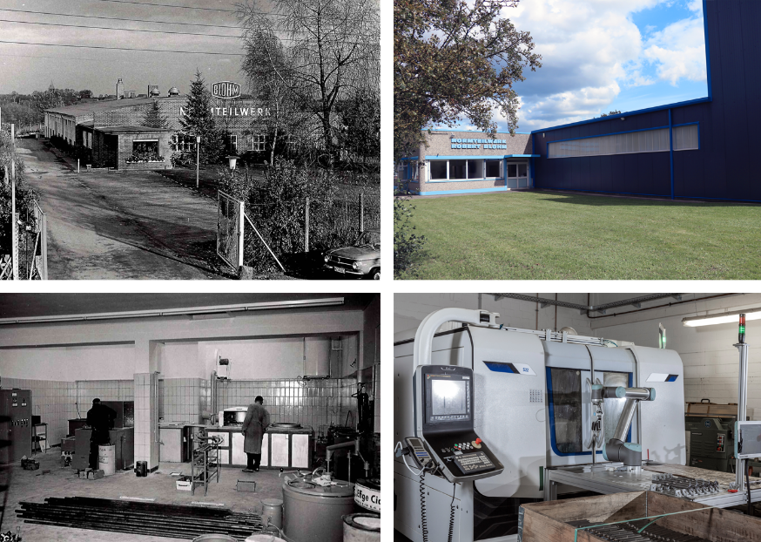

Yesterday and today: The family business ROBERT BLOHM started manufacturing drill bushes in Hamburg city centre in 1934. Since 2021, BLOHM has been contributing its long experience in the fields of turning, hardening and precision grinding to the KIPP Group as one of its successful business units.
Image: NORMTEILWERK ROBERT BLOHM GmbH



Otto Braun, CEO at BLOHM: “We will continue to optimise both our processes and our portfolio over the next few years. With creativity and innovation, we will evolve into a successful unit within the KIPP Group.”
Image: NORMTEILWERK ROBERT BLOHM GmbH
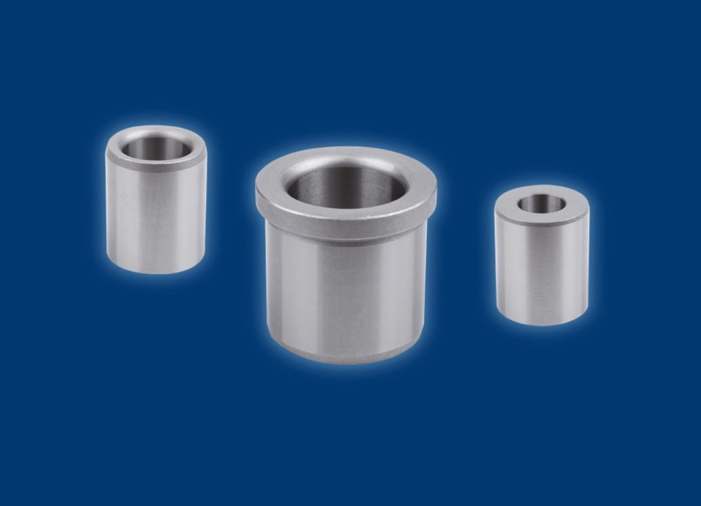
A landmark anniversary, and good cause to celebrate – BLOHM’s drill bush is turning 90 and is as popular as ever. Launched in 1934, the current portfolio now comprises more than 3000 types of product. Common to all is their high quality and precision.
Image: NORMTEILWERK ROBERT BLOHM GmbH

Meta title: BLOHM celebrates its 90th anniversary

Meta description: BLOHM’s drill bush is 90 years old. The long-established Büchen-based company has stood for quality and precision made in Germany since 1934.

Keywords: NORMTEILWERK ROBERT BLOHM, BLOHM, special manufacturing, special solutions, customised special production, standard parts, operating parts, drill bushes, push-in drill bushes, flanged drill bushes, drill bush clamps, HEINRICH KIPP WERK, KIPP Group

Deeplinks:
https://www.blohm-gmbh.de/de/de/Home.html
https://www.blohm-gmbh.de/de/de/Produkte/Produktübersicht.html
https://www.blohm-gmbh.de/de/de/Produkte/Produktübersicht/Bohrbuchsen/Bohrbuchsen.html

Download area:
https://www.blohm-gmbh.de/de/de/Download/Pressebereich.html

NORMTEILWERK ROBERT BLOHM GmbH
Adriana Klink
Bahnhofstraße 20
21514 Büchen, Germany
Telephone: +49 7454 793-7648
Fax: +49 7454 793-133
Email: adriana.klink@blohm-gmbh.de

Press office:
Köhler + Partner GmbH
Brauerstrasse 42 • 21244 Buchholz i.d.N.
Telephone +49 4181 92892-0 • Fax +49 4181 92892-55
info@koehler-partner.de • www.koehler-partner.de

