The one-stop shop for machine components gains a renowned addition
Drill bushes from BLOHM complement the MISUMI range

The MISUMI online shop contains millions of components The manufacturer and supplier of machine components is continuously expanding its product portfolio in order to offer its customers an even greater choice. As of recently, this also includes high-quality drill bushes from NORMTEILWERK ROBERT BLOHM.

MISUMI has been supplying its customers with machine components of its own manufacture and from other well-known companies for more than 20 years. The component specialist's portfolio has grown over the years and now includes more than 700 partner brands. Most of them with CAD data for immediate download. MISUMI recently expanded its already diverse product portfolio to include DIN-standard drill bushes from the manufacturer BLOHM.

BLOHM has been manufacturing rotationally symmetrical parts in various styles for over 80 years. These are used in a wide variety of applications. Drill bushes precisely guide drills in a machine. This enables the user to machine workpieces with high precision and easily maintain pitch and angle tolerances.

Two of these components are now available in MISUMI-Shop : The DIN 179 cylindrical drill bushes can be easily pressed into the corresponding adapters and combined with the DIN 173 replaceable drill bush. The second addition is the DIN 172 flanged drill bushes, which are particularly characterised by their axial locking, which ensures that the bush always remains in position even under high loads. Both components are available with a rounded bore on one or both sides, depending on customer preference, and have a long service life due to the use of hardened special steel.

"With BLOHM, we have gained another prominent name for our online shop. We are delighted to be associated with this partnership," summarises Dietmar Theisen, Director European Distribution Supplier Development at MISUMI.

Stand: 15th November 2023
Contents: 1,962 characters (incl. spaces)

About MISUMI
MISUMI is a global manufacturer and leading supplier of more than 20 million components and indirect materials for mechanical engineering and assembly automation A significant number of MISUMI products can be individually configured. Founded in Tokyo in 1963, the company has sales offices worldwide and employs more than 12,000 people. For 16 years, the European headquarters have been located in Frankfurt am Main, Germany. The MISUMI business model is based on highest quality, low costs and short delivery times and appeals to more than 300,000 customers around the globe.

More information under www.misumi-europe.com.

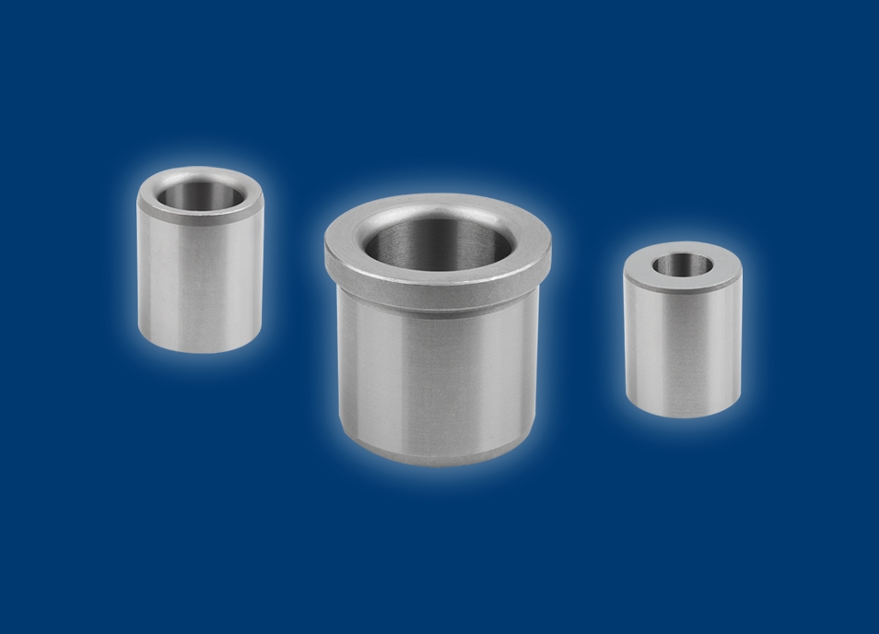

Drill bushes precisely guide drills in a machine.
Picture: BLOHM

