Buechen, October 2023

BLOHM is at the Suppliers' Trade Show FMB in Bad Salzuflen from the 8th to 10th November
From standard parts to special solutions

At the FBM 2023, the NORMTEILWERK ROBERT BLOHM, Büchen will be showcasing itself as a competent and versatile partner to mechanical engineering. The specialists for the production and distribution of standard and precision parts will be presenting a selection of their extensive product portfolio. One focus is on individual special solutions, which BLOHM develops and implements together with the customer on the basis of ultra-modern production technology and decades of expertise.

BLOHM will not only present a large selection of drill bushes, standard and operating parts at the FMB, but will also highlight its extensive expertise and possibilities in the area of customised special production. With decades of experience in the industry, the Büchen-based company has established itself as a trustworthy partner for tailor-made solutions in this field. The customer benefits from high-performance machining technology and a highly qualified team of experts. The customised solutions can be made from steel or stainless steel and are used, among others, in machine construction, the automotive industry and in the aerospace industries.

Individual solutions for customer-specific requirements
Examples of customised machine elements from BLOHM include pinion shafts, traverse and drive spindles and polygon shafts. All these special parts are made of durable quality steel and are turned, hardened and ground at the production site in Büchen in northern Germany.

- Pinion shafts connect pinion and drive shaft in one component. They are compact and efficient and, due to these properties, are the preferred choice in the automotive industry, aerospace and general mechanical engineering for the transmission of high torques. The one-piece assembly is usually made from a single piece of steel.
- Traverse and drive spindles are used, among other things, in coolant pumps of lathes, milling machines or grinding machines. Thanks to its highly efficient machine park, BLOHM manufactures these demanding components to the highest precision, even with complex geometries.
- Polygon shafts have a polygonal cross-section, which is based on e.g. an equilateral triangle or a square. Due to their high centring precision and simultaneously greatly reduced stress concentration, polygon shaft connections are very well suited for the transmission of high torques and are used, among other things, in manual transmissions.

The correct drill bush for diverse requirements
As a specialist for rotationally symmetrical parts, BLOHM manufactures an extensive range of standardised drill bushes. As with all BLOHM products, the drill bushes are manufactured on modern machines from hardened, wear resistant quality steel. Drill bushes enable precise drill guidance and the correspondingly rapid and accurate machining of workpieces. Pitch and angular tolerances can be precisely maintained. Furthermore, drill bushes are used in the manufacture of clamping and measuring devices. BLOHM offers various designs of drill bushes for differing requirements. In addition to DIN 179 cylindrical drill bushes, the range also includes among others DIN 172 flanged drill bushes and DIN 173 push-in drill bushes and drill bush clamps.

More than 28,000 standard and operating parts
When developers, designers or production managers are also looking for spring plungers, indexing plungers or ball lock pins for machines and fixtures, then by NORMTEILWERK ROBERT BLOHM they are at the right address. In the online shop of the Büchen-based company, the user will find a total of more than 28,000 items and hence, always a perfect solution. At the FMB in Bad Salzuflen, BLOHM will present a cross-section of its extensive portfolio.

Visit us from 8-10 November at the FMB 2023 in Bad Salzuflen in Hall 20, Booth C6.

(Characters including spaces: 4,023)

Short profile about NORMTEILWERK ROBERT BLOHM

NORMTEILWERK ROBERT BLOHM, founded in Schleswig-Holstein in 1934, is a renowned manufacturer of drill bushes, operating and standard parts as well as sophisticated special solutions based on customer drawings. For more than 80 years, BLOHM has been an internationally renowned specialist for the production of rotationally symmetrical parts and has always stood for the highest precision and quality.
Our portfolio includes around 28,000 high-quality products that, due to their stability can withstand high loads and also meet special requirements. This means that we can primarily target partners from trade and industry who rely on durable and high-quality parts. We have our own high-performance and modern machine park at our disposal for the production of precision parts. Possible areas of application for the various bushes and standard parts are machine, special machine and plant construction and mould and tool making. We value long-term partner relationships with our customers, highest quality and on-time delivery. With an eye on the future, we have also been providing training for the next generation of skilled workers for decades.

Image overview:
Blohm_Sonderfertigung.jpg
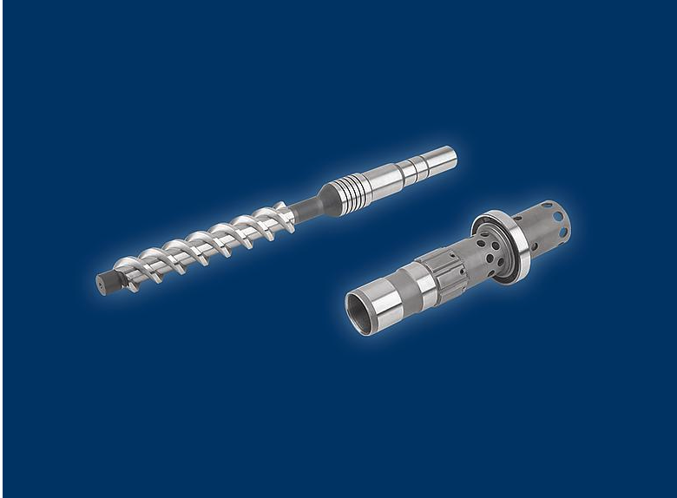
With many years of experience and well-founded know-how, NORMTEILWERK ROBERT BLOHM is precisely the right contact when it comes to special machine elements for special machine construction.
Image: NORMTEILWERK ROBERT BLOHM GmbH

Blohm_Normteile.jpg
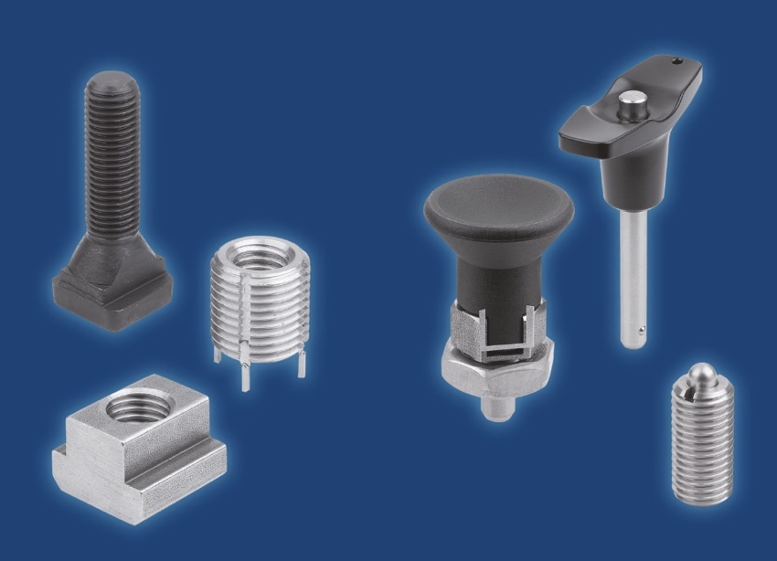
When it comes to standard and operating parts, developers, designers and production managers have come to the right web address at NORMTEILWERK ROBERT BLOHM. In the company's online shop there are more than 28,000 items and thus, always a suitable solution.
Image: NORMTEILWERK ROBERT BLOHM GmbH

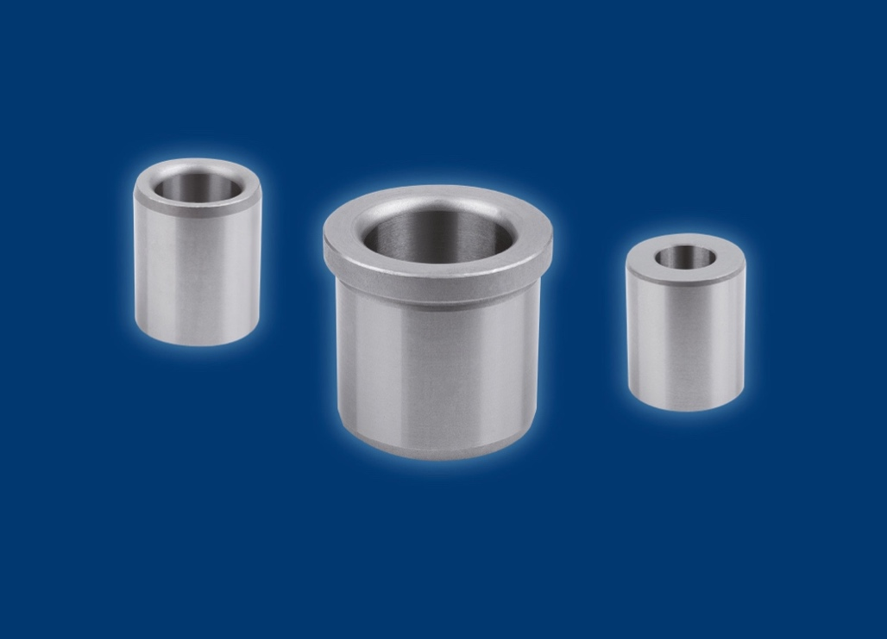
For the rapid and precise machining of workpieces, the user will find a large selection of various types and sizes of standardised drill bushes at BLOHM.
Image: BLOHM
Meta title: BLOHM at the FMB 2023 from 8th to 10th November

Meta description: In addition to drill bushes, standard and operating parts, NORMTEILWERK ROBERT BLOHM will be showcasing its competence in the field of special component manufacturing at the FMB 2023.

Keywords: NORMTEILWERK ROBERT BLOHM, BLOHM, special manufacturing, special solutions, customer-specific special solution, travers spindle, polygon shaft, spring plunger, indexing plunger, ball lock pin, machine components, fixture components, standard elements, operating parts, drill bushes, push-in drill bushes, flanged drill bushes, drill bush clamps

Deeplinks:
https://www.blohm-gmbh.de/de/de/Messen.html
https://www.blohm-gmbh.de/de/de/Home.html
https://www.blohm-gmbh.de/de/de/Produkte/Sonderlösungen.html
https://www.blohm-gmbh.de/de/de/Produkte/Produktübersicht/Bohrbuchsen.html
https://www.blohm-gmbh.de/de/de/Produkte/Produktübersicht.html

Download Area:
https://www.blohm-gmbh.de/de/de/Download/Pressebereich.html

NORMTEILWERK ROBERT BLOHM GmbH
Adriana Klink
Bahnhofstraße 20
21514 Büchen, Germany
Telephone: +49 7454 793-7648
Fax: +49 7454 793-133
Email: adriana.klink@blohm-gmbh.de

Press office:
Köhler + Partner GmbH
Brauerstrasse 42 • 21244 Buchholz i.d.N.
Telephone +49 4181 92892-0 • Fax +49 4181 92892-55
info@koehler-partner.de • www.koehler-partner.de

