Büchen, July 2023

BLOHM has a large portfolio of spring plungers, indexing plungers and ball lock pins
The perfect ID point for every design

Often it is the small stuff that makes the big things really good. When developers, designers or production managers are looking for spring plungers, indexing plungers or ball lock pins for machines and fixtures, then by NORMTEILWERK ROBERT BLOHM they are at the right web address. In the online shop of the specialists for standard and operating parts, the user will find a total of more than 28,000 items and hence, always a perfect solution.

BLOHM covers a diverse range of applications with spring plungers made of plastic, steel, stainless steel, ceramics and various material combinations. The plastic variants are not only light and inexpensive but, due to their corrosion resistance are also highly suitable for outdoor use or for environments with high humidity. The types with steel sleeves and/or balls are the perfect solution where high forces are applied to the plungers or where the operating conditions are harsh and the temperature fluctuations are high. Stainless steel spring plungers combine all the above advantages: they are corrosion and temperature resistant and lighter than comparable steel versions. BLOHM offers spring plungers with a ceramic ball for applications where not only temperature but also chemical resistance is required. These are robust and low-wearing and are therefore also ideally suited for applications with high cycle rates.

Indexing plungers and ball lock pins
Indexing plungers facilitate fast and easy adjustment of movable components. BLOHM provides the user with an extensive range of products made of steel, stainless steel or plastic with and without a locking slot. Thanks to the wide range of different models, the indexing plungers can be used in every conceivable field, e.g. for positioning tasks in machine construction, assembly equipment, filling and packaging plants in the food industry or for indexing and locking in the field of automotive technology.

If two parts or workpieces are to be simply connected or secured during processing, the user can make the appropriate selection from a large range of ball lock pins on the BLOHM website. Various grip shapes and materials are available depending on the application. For example, for harsh environments and high force applications, a choice can be made between different ball lock pins with high shear strength. Available materials are plastic, die-cast zinc and stainless steel.

Machine and fixture elements
The selection of machine and fixture elements in the BLOHM online shop includes around 5,000 products. The designer will find here a wide range of screws, nuts, washers, threaded inserts and shaft collars, amongst other things. The items from the above listed categories are available in bright, electro zinc-plated or black oxidised steel, or bright stainless steel. Depending on the application, a choice can be made between different strength grades.

If a damaged, siezed up or torn out tapped hole needs to be repaired, then the user will find a range of steel and stainless steel threaded inserts from BLOHM. The thread inserts are suitable for a wide range of materials and restore the functionality of even high-quality products in the shortest possible time.

(Characters including spaces: 3,445)

Short profile about NORMTEILWERK ROBERT BLOHM

NORMTEILWERK ROBERT BLOHM, founded in Schleswig-Holstein in 1934, is a renowned manufacturer of drill bushes, operating and standard parts as well as sophisticated special solutions based on customer drawings. For more than 80 years, BLOHM has been an internationally renowned specialist for the production of rotationally symmetrical parts and has always stood for the highest precision and quality.
Our portfolio includes around 28,000 high-quality products that, due to their stability can withstand high loads and also meet special requirements. This means that we can primarily target partners from trade and industry who rely on durable and high-quality parts. We have our own high-performance and modern machine park at our disposal for the production of precision parts. Possible areas of application for the various bushes and standard parts are machine, special machine and plant construction and mould and tool making. We value long-term partner relationships with our customers, highest quality and on-time delivery. With an eye on the future, we have also been providing training for the next generation of skilled workers for decades.

Image overview:

Blohm_Normteile.jpg
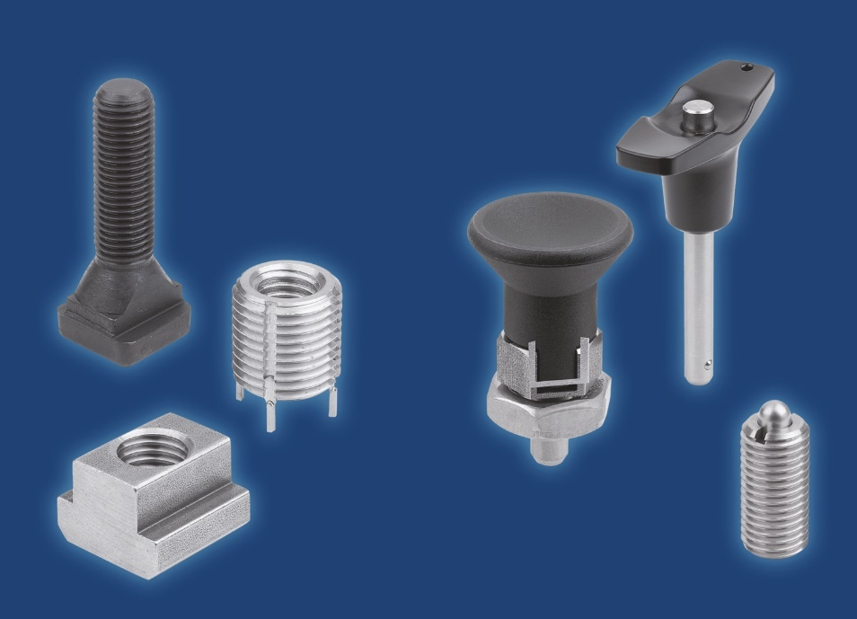
When developers, designers or production managers are looking for spring plungers, indexing plungers or ball lock pins for machines and fixtures, then by NORMTEILWERK ROBERT BLOHM they are at the right web address. In the online shop of the specialists for standard and operating parts, the user will find a total of more than 28,000 items and hence, always a perfect solution.
Image: NORMTEILWERK ROBERT BLOHM GmbH

Meta title: Spring plungers, indexing plungers and ball lock pins from BLOHM

Meta description: With more than 28,000 standard and operating parts, NORMTEILWERK ROBERT BLOHM offers the perfect solution for every application.

Keywords: NORMTEILWERK ROBERT BLOHM, BLOHM, spring plungers, indexing plungers, ball lock pins, machine elements, fixture elements, screws, nuts, washers, threaded inserts, shaft collars, standard parts, operating parts

Deeplinks:
https://www.blohm-gmbh.de/de/de/Home.html
https://www.blohm-gmbh.de/de/de/Produkte/Produktübersicht/Federnde-Druckstücke-Arretierbolzen-Kugelsperrbolzen.html
https://www.blohm-gmbh.de/de/de/Produkte/Produktübersicht/Maschinenelemente-Vorrichtungselemente.html

Download Area:
https://www.blohm-gmbh.de/de/de/Download/Pressebereich.html

NORMTEILWERK ROBERT BLOHM GmbH
Adriana Klink
Bahnhofstraße 20
21514 Büchen, Germany
Telephone: +49 7454 793-7648
Fax: +49 7454 793-133
Email: adriana.klink@blohm-gmbh.de

Press office:
Köhler + Partner GmbH
Brauerstrasse 42 • 21244 Buchholz i.d.N.
Telephone +49 4181 92892-0 • Fax +49 4181 92892-55
info@koehler-partner.de • www.koehler-partner.de

