Büchen, May 2023

First class quality and precision

**BLOHM impresses with drill bushes and a new range of standard and operating parts**

**As a specialist for rotationally symmetrical parts, NORMTEILWERK ROBERT BLOHM manufactures various standardised drill bushes that can be interchanged or replaced as required. As with all BLOHM products, these are manufactured using the most modern machines, and are made from hardened and wear-resistant quality steel.**

Drill bushes enable rapid and accurate machining of workpieces because the drill in the machine is precisely guided through the bush. This creates a uniform hole pattern on all machined parts. Furthermore, pitch and angular tolerances can be precisely maintained through the use of drill bushes. The bushes also reduce the risk of drill breakages.  
However, the bushes are not only used to ensure precise drill guidance but, due to new manufacturing processes, are also used in the manufacture of clamping and measuring fixtures.   
Due to the use of durable, hardened special steels and the low wear on components, there are also significant cost savings.

**Find the correct drill bush for diverse requirements**   
BLOHM offers different types of drill bushes to suit various applications. In addition to DIN 179 cylindrical drill bushes, the range also includes DIN 172 flanged drill bushes as well as DIN 173 push-in drill bushes and drill bush clamps.

Two types of **cylindrical drill bushes** are available: with the bore rounded at one end or both ends. They can be precisely pressed into the holder and are easily combined with the DIN 173 push-in drill bushes.  
**Flanged drill bushes** offer axial security and hold the bush in position. Two types of these are also available: with the bore rounded at one end or both ends.   
In contrast to cylindrical drill bushes, **push-in drill bushes** can be quickly and easily exchanged. These are available as so called exchangeable bushes or quick-change bushes. Even more precise results can be achieved when used in combination with flat head screws and drill bush clamps from BLOHM.  
**Drill bush clamps** are used for additional securing of push-in drill bushes and are available in different sizes: to suit push-in bushes with ID 5.1; 6.1; 8.1 und 10.1 mm.

**BLOHM offers even more**NORMTEILWERK ROBERT BLOHM has expanded its product range with standard and operating parts to more than 28,000 items. These are available from the online shop.

On our website you will find comprehensive information about our first class drill bushes and other precision parts.

(Characters including spaces: 2,660)

**Short profile about NORMTEILWERK ROBERT BLOHM**

NORMTEILWERK ROBERT BLOHM, founded in Schleswig-Holstein in 1934, is a renowned manufacturer of drill bushes, operating and standard parts as well as sophisticated special solutions based on customer drawings. For more than 80 years, BLOHM has been an internationally renowned specialist for the production of rotationally symmetrical parts and has always stood for the highest precision and quality.   
Our portfolio includes around 28,000 high-quality products that, due to their stability can withstand high loads and also meet special requirements. This means that we can primarily target partners from trade and industry who rely on durable and high-quality parts. We have our own high-performance and modern machine park at our disposal for the production of precision parts. Possible areas of application for the various bushes and standard parts are machine, special machine and plant construction and mould and tool making. We value long-term partner relationships with our customers, highest quality and on-time delivery. With an eye on the future, we have also been providing training for the next generation of skilled workers for decades.

**Image overview:**

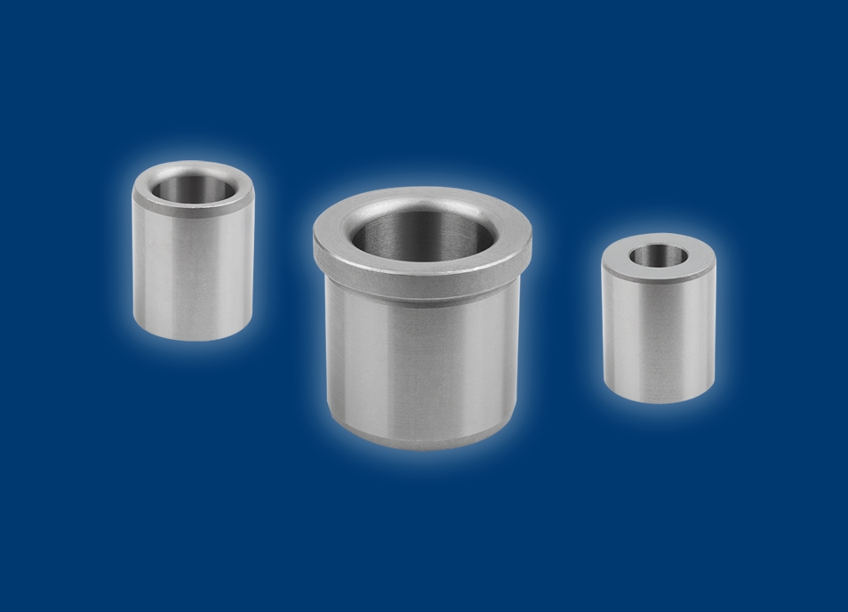

Drill bushes enable rapid and accurate machining of workpieces because the drill in the machine is precisely guided through the bush.

*Image: BLOHM*

**Meta title:** BLOHM impresses with drill bushes and new operating parts

**Meta description:** NORMTEILWERK ROBERT BLOHM manufactures drill bushes from hardened quality steel and has expanded its range of operating parts.

**Keywords:** NORMTEILWERK ROBERTBLOHM, BLOHM, rotationally symmetrical parts, standard parts, precision parts, drill bushes, push-in bushes, flanged bushes, drill bush clamps, flat head screws

**Deeplinks:**

<https://www.blohm-gmbh.de/de/de/Unternehmen.html>  
<https://www.blohm-gmbh.de/de/de/Download/Prospekte.html>

**Download Area:**

<https://www.blohm-gmbh.de/de/de/Download/Pressebereich.html>

**NORMTEILWERK ROBERT BLOHM GmbH**

Adriana Klink  
Bahnhofstraße 20  
21514 Büchen, Germany

Telephone: +49 7454 793-7648  
Fax: +49 7454 793-133  
Email: [adriana.klink@blohm-gmbh.de](mailto:adriana.klink@blohm-gmbh.de)

**Press office:**

Köhler + Partner GmbH

Brauerstrasse 42 · 21244 Buchholz i.d.N.

Telephone +49 4181 92892-0 · Fax +49 4181 92892-55

info@koehler-partner.de · www.koehler-partner.de