Büchen, January 2023

After the introduction of a quality management system

**BLOHM obtains DIN ISO 9001:2015 certification**

**In December 2022 the NORMTEILWERK ROBERT BLOHM aquired the** [**Initial certification**](https://www.blohm-gmbh.de/de/en/News/BLOHM-News/Successful-initial-certification-for-BLOHM.html) **according to the latest standards for quality management DIN ISO 9001:2015. The company impressed during the certification not only with a pragmatic approach, but also with the comprehensive implementation of the QM (Quality Management) system. The good working atmosphere and the motivation of the staff also attracted positive attention.**

"The QM system at BLOHM does not merely exist - it is actually embraced by the employees" - The auditor made this statement during the final interview. Praise that makes Jochen Herre, the quality management coordinator (QMC) at BLOHM particularly happy: "It shows that we did everything right in the run-up to the certification. We want to ensure quality in all our processes - this only works if the entire team is on board."

Customers benefit from these quality-assurance measures through e.g. rapid quotation preparation and order processing, because efficiency could be significantly increased in production as well as in the warehouse and dispatch.

To achieve this, various quality control procedures were introduced - among them are additional inspections during production. In addition, BLOHM has introduced complaints processing according to the 8D logic method and improved the labelling and traceability of products. In purchasing, supplier evaluation indicates measurable key figures for the suppliers, while staff training plans ensure continuous job training. " Overall, all processes now have defined structures, higher process stability and increased quality assurance measures - and that right from order placement through to delivery," says Jochen Herre. "This enables us to further improve customer satisfaction."

In order to further optimise quality management in the medium and long term, the CIP (continuous improvement process) concept is an integral part of BLOHM's QM system: All processes are regularly reviewed and, if necessary, adapted. This is done according to the PDCA principle (Plan, Do, Check, Act).

(Characters including spaces: 2,132)

**Image overview:**

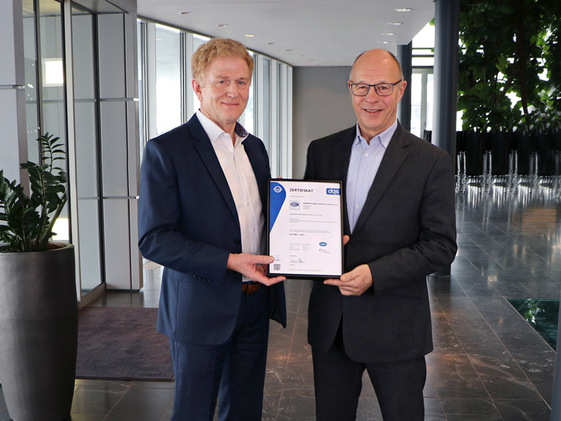

Managing directors Otto Braun (left) and Volker Göbel are delighted to accept the ISO 9001:2015 certification.

*Image: NORMTEILWERK ROBERT BLOHM GmbH*

**Meta-Title:** BLOHM DIN ISO 9001:2015 certified

**Meta-Description:** Customers benefit from the quality assurance measures in many ways. Find out more here!

**Deeplinks**:

<https://www.blohm-gmbh.de/de/en/News/BLOHM-News/Successful-initial-certification-for-BLOHM.html>

**Keywords:** BLOHM, Quality management, QM system, ISO certification

**Download Area:**

<https://www.blohm-gmbh.de/de/en/Download/Press-area.html>

**NORMTEILWERK ROBERT BLOHM GmbH**

Adriana Klink  
Bahnhofstraße 20  
21514 Büchen, Germany  
  
Telephone: +49 7454 793-7648  
Fax: +49 7454 793-133  
Email: [adriana.klink@blohm-gmbh.de](mailto:adriana.klink@blohm-gmbh.de)

**Press office:**

Köhler + Partner GmbH

Brauerstrasse 42 · 21244 Buchholz i.d.N.

Telephone +49 4181 92892-0 · Fax +49 4181 92892-55

info@koehler-partner.de · www.koehler-partner.de